Operational Specification Template
Student | Hristina Koleva | Date | 08.06.2013
Program | PSP Assignment 5 | Program # | 5
Instructor | Valentina Ivanova | Language | C#

Scenario Number | 1 | User Objective | Determine the value for probability density
Scenario Objective |  | User enter the degrees of freedom value for the calculations
Source | Step | Action |  | Comments
User | 1 | User launches the calculating application
Application | 2 | Application is launched
User | 3 | User enters required input value  User presses Enter
Application | 4 | Application visualizes the result for the input value
Scenario Number | 2 | User Objective | Determine the value for probability density
Scenario Objective |  | Application validates user input
Source | Step | Action |  | Comments
User | 1 | User launches the calculating application
Application | 2 | Application is launched
User | 3 | User enters required input value  User presses Enter
Application | 4 | Application prompt the user that the calculations cannot proceed with the value entered since it is not a valid one

Functional Specification Template

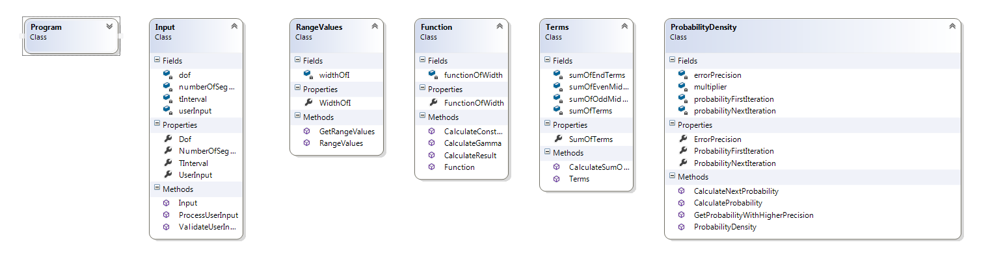
Student |  |  | Hristina Koleva |  | Date | 08.06.201
Program |  |  | PSP Assignment 5 |  | Program # | 5
Instructor |  |  | Valentina Ivanova |  | Language | C#
Class Name |  | Program
Parent Class
Attributes
 | Declaration |  |  | Description
Items
 | Declaration |  |  | Description
 | Main() |  |  | Launches the application and calls the execution of the program

Class Name |  | UserInput
Parent Class
Attributes
 | Declaration |  | Description
 | dof |  | User input to select the degrees of freedom to be used in the calculations of Student’s  t-distribution probability density function
 | tInterval |  | End of functionOfWidth range
 | NumberOfSegments |  | Initially = 10
Items
 | Declaration |  | Description
 | ValidateUserInput() |  | Validates the user input from key board as a numeric value
 | ProcessUserInput() |  | Sets tInterval depending on the entered dof

Class Name |  | RangeValues
Parent Class
Attributes
 | Declaration |  | Description
 | dof |  | Uses dof from UserInput
 | WidthOfI |  | The range of function parameters  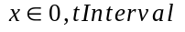
 | tInterval |  | End of widthOfI range
 | numberOfSegments
Items
 | Declaration |  | Description
 | GetRangeValues() |  | widthOfI[i] = i * tInterval / numberOfSegments;

Class Name |  | Terms
Parent Class
Attributes
 | Declaration |  | Description
 | dof |  | User input to select the degrees of freedom to be used in the calculations of Student’s  t-distribution probability density function
 | functionOfWidth |  | The range of function parameters
 | tInterval |  | End of functionOfWidth range
 | SumOfEndTerms |  | Calculate F(0) + F(X)
Items
 | Declaration
 | CalculateSumOfTerms() |  | 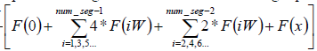

Class Name |  | Function
Parent Class
Attributes
 | Declaration |  | Description
 | dof |  | User input to select the degrees of freedom to be used in the calculations of Student’s  t-distribution probability density function
 | functionOfWidth |  | The range of function parameters
 | tInterval |  | End of functionOfWidth range
 | WidthOfI |  | X as returned by RangeValues
Items
 | Declaration |  | Description
 | CalculateGamma() |  | 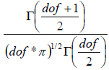  Calculates the constant function part of gamma function of parameter dof
 | CalculateConstant() |  | 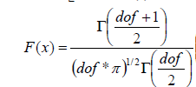
 | CalculateResult() |  | Calculates F(X) for each widthOfI as multiplies the result of CalculateConstant() and the variable part of the function and returns the output of the function  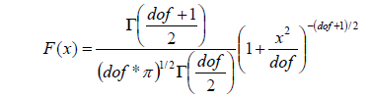

Class Name |  | ProbabilityFunction
Parent Class |  | Program
Attributes
 | Declaration |  | Description
 | dof |  | From UserInput
 | numberOfSegments |  | From UserInput
 | Tinterval |  | From UserInput
 | resultFunction |  | Uses result calculated in CalculateResultFunction() of CalculateFunction class
 | probabilityFirstIterationN |  | The output result of the application, calculated in CalculateProbability() method using firstNumberOfSegments
 | probabilityNextIteration |  | The output result of the application, calculated in CalculateProbability() method using numberOfSegments*2
 | errorTolerance |  | Constant used to determine the error tolerance which the calculations must satisfy
 | IsMoreAccurate |  | A boolean value to determine the more reliable result that satisfies the errorTolerance condition
 | Multiplier |  | Multiplier = tInterval/numberOfSegments*3
Items
 | Declaration |  | Description
 | CalculateProbability() |  | Calculates the output of the application by summarizing the terms and multiplying them by the Width coefficient  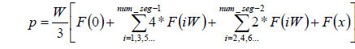
 | CalculateNextProbability() |  | Sets numberOfSegments to numberOfSegmetns*2 and recalculates the probability
 | GetProbabilityWithHigherPrecision() |  | Check is probabilityFirstIteration – probabilityNextIteration < errorPrecision  if Not gets probabilityNextIteration if Yes recalculates probabilityNextIteration

Logic Specification Template

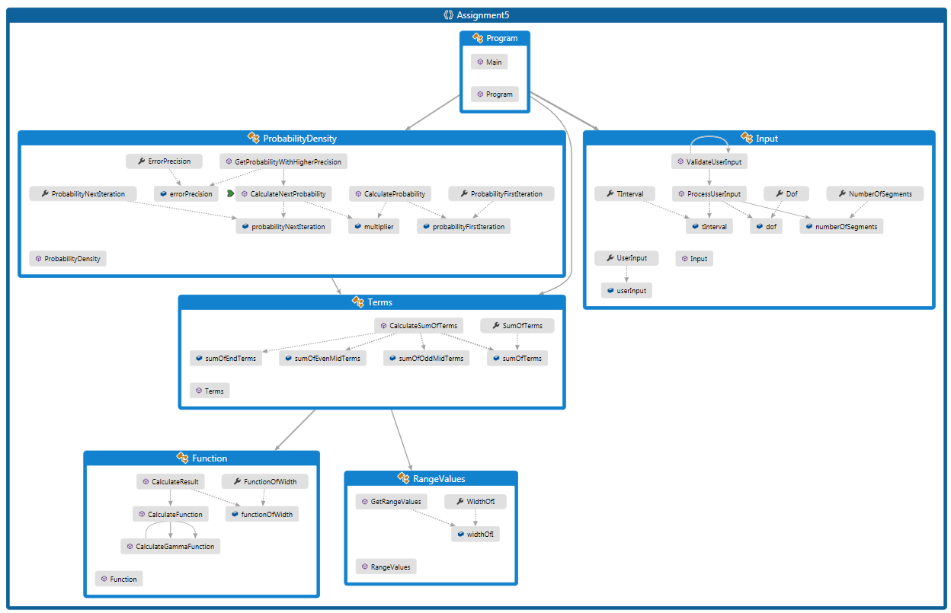

Student | Hristina Koleva | Date | 09.06.2013
Program | PSP Assignment 5 | Program # | 5
Instructor | Valentina Ivanova | Language | C#

Design
References

Parameters | dof
 | tInerval
 | functionOfWidth
 | errorTolerance
 | isMoreAccurate
 | numberOfSegments
 | probabilityFirstIteration
 | probabilityNextIteration
 | sumOfTerms
 | widthOfI
 | isValidUserInput
 | userInput
 | sumOfOddTerms
 | sumOfEvenTerms
 | multiplier

ValidateUserInput()
Read userInput
While userInput is valid
Call ProcessUserInput()
Else Return
ProcessUserInput()
Case IserInput of
UserInput = 9 : tInterval = 1.1;
UserInput = 10: tInterval = 1.1812;
UserInput = 30: tInterval = 2.750;
GetRangeValues()
For I = 0; I <numberOfsegments+1; I ++
WidthOfI[i] = i*tInterval/numberOfSegments
CalculateGamma(dof)
If dof == 1 return 1
If dof == 0.5 return 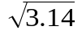
Return (dof-1)*CalculateGamma(dof+1)
CalculateConstant()
Return CalculateGamma((dof + 1) / 2) /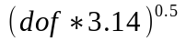*CalculateGamma(dof/2)
CalculateResult()
For I = 0; I < numberOfSegments +1; i++
FunctionOfWidth[i] = CalculateConstant(dof)*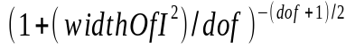
CalculateSumOfTerms()
SumOfEndTerms = funtionOfWidth[0] + functionOfWidth[tInterval]
For I = 1; I < numberOfSegments; I+=2
sumOfOddTerms[i] = functionOfWidth[i]*4
SumOfTerms += sumOfOddTerms[i]
For J = 2; J < numberOfSegments; J +=2
sumOfEvenTerms[j] = functionOfWidth[i]*2;
SumOfTerms += sumOfEvenTerms
SumOfTerms += sumOfEndTerms;
CalculateProbability()
Multiplier = tInterval/numberOfSegments*3
ProbabilityFirstIteration = multiplier*sumOfTerms
CalculateNextProbability()
NumberOfSegments = numberOfSegments*2
Call CalculateSumOfTerms()
Multiplier = tInterval/numberOfSegments*3
ProbabilityNextIteration = multiplier*sumOfTerms
GetProbabilityWithHigherPrecision()
ErrorPrecision = 0.0000001
IsNextMoreAccurate = false
While isNextMoreAccurate = false
If (probabilityFirstIteration – probabilityNextIteration > errorPrecision)
Call CalculateNextProbability()
Return probabilityNextIteration
IsNextMoreAccurate = true
Else
Return ProbabilityFirstIteration

